Accessing Databases with JDBC.

Firstly set up the database.
Download and install the server and the java driver software.

http://dev.mysql.com/downloads/mysql/5.0.html

and

http://dev.mysql.com/downloads/connector/j/5.1.html

setup the user account

create a database books

tables
authors: id, first name, lastname
author-isbn : id, isbn
titles: isbn, title, edition no, copyright.

Start the database in a dos box by going to the directory and typing
Mysqld-nt.exe

// Displaying the contents of the authors table.
import java.sql.Connection;
import java.sql.Statement;
import java.sql.DriverManager;
import java.sql.ResultSet;
import java.sql.ResultSetMetaData;
import java.sql.SQLException;

public class DisplayAuthors
{
// database URL
static final String DATABASE_URL = "jdbc:mysql://localhost/books";

// launch the application
public static void main( String args[] )
{
Connection connection = null; // manages connection
Statement statement = null; // query statement
ResultSet resultSet = null; // manages results

// connect to database books and query database
try
{
// establish connection to database
connection = DriverManager.getConnection(
DATABASE_URL, "deitel", "deitel" );

// create Statement for querying database
statement = connection.createStatement();

// query database
resultSet = statement.executeQuery(
"SELECT authorID, firstName, lastName FROM authors" );

// process query results
ResultSetMetaData metaData = resultSet.getMetaData();
int numberOfColumns = metaData.getColumnCount();
System.out.println( "Authors Table of Books Database:\n" );

for ( int i = 1; i <= numberOfColumns; i++ )
System.out.printf( "%-8s\t", metaData.getColumnName( i ) );
System.out.println();

while ( resultSet.next() )
{
for ( int i = 1; i <= numberOfColumns; i++ )
System.out.printf( "%-8s\t", resultSet.getObject( i ) );
System.out.println();
} // end while
} // end try
catch ( SQLException sqlException )
{
sqlException.printStackTrace();
} // end catch
finally // ensure resultSet, statement and connection are closed
{
try
{
resultSet.close();
statement.close();
connection.close();
} // end try
catch ( Exception exception )
{
exception.printStackTrace();
} // end catch
} // end finally
} // end main
} // end class DisplayAuthors

/**************************************************************************
* (C) Copyright 1992-2010 by Deitel & Associates, Inc. and *
* Pearson Education, Inc. All Rights Reserved. */

To run the program
Tell the system where the java driver is
Java –classpath .;c:\mysql-connector-java-5.1.11\mysql-connector-java-5.1.11-bin.jar DisplayAuthors

Otherwise copy the file mysql-connector-java-5.1.11-bin.jar to the \jre\lib\ext directory then use
Java DisplayAuthors

Connection object connect via the method getconnection of class drivermanager. Provide url database username and password.

Connection method createstatement returns an object that implements Statement interface of package java.sql. Use a statement to manipulate the db.

Statement object’s method executequery returns an object that implement the resultsset interface. This contains the query result.

Resultssetmetadata is data about the results. This can getcolumncount.

The loop displays all the rows of the resultsset. Uses getobject.

Finally closes the resultset, statement and db connection…

It is more common to separate out the db interaction into a separate class, creating two tiers. This class should implement the singleton pattern, so that there is only one instance of it interacting with the database so as to avoid update anomillies.

We then synchronize the methods so that only one access at a time ensuring database integrity.

Code:

import java.sql.*;
import java.sql.Connection;
import java.sql.Statement;
import java.sql.DriverManager;
import java.sql.ResultSet;
import java.sql.ResultSetMetaData;
import java.sql.SQLException;

public class BooksRepository {

private static BooksRepository instance;
private static final String user="deitel" ;
private static final String password="deitel";
private static final String DATABASE_URL = "jdbc:mysql://localhost/books";

private Connection connection = null;
private PreparedStatement statement;

public static BooksRepository getInstance() throws bookRepositoryException
{
if (instance == null)
instance = new BooksRepository();
return instance;
}

private BooksRepository () throws bookRepositoryException
{
String getAuthors= "SELECT authorID, firstName, lastName FROM authors";
try {
connection = DriverManager.getConnection( DATABASE_URL, user, password );
statement = connection.prepareStatement(getAuthors);

}catch (SQLException se) {
throw new bookRepositoryException(se.getMessage());
}
}

void outputAuthors() throws bookRepositoryException
{
try {
ResultSet results;
synchronized (statement) {
results = statement.executeQuery();
}
// process query results
ResultSetMetaData metaData = results.getMetaData();
int numberOfColumns = metaData.getColumnCount();
System.out.println( "Authors Table of Books Database:\n" );

for ( int i = 1; i <= numberOfColumns; i++ )
System.out.printf( "%-8s\t", metaData.getColumnName( i ) );
System.out.println();

while ( results.next() )
{
for ( int i = 1; i <= numberOfColumns; i++ )
System.out.printf( "%-8s\t", results.getObject( i ) );
System.out.println();
} // end while
}
catch (Exception e){}
} // end try

public void destroy () {
if ( connection != null) {
try { connection.close();
results.close();
statement.close(); }
catch (Exception e ){}
}
}

}

public class usesbookrepository {

public static void main (String args[])
{
try {
BooksRepository bkr =null;
bkr = bkr.getInstance();
bkr.outputAuthors();
bkr.destroy();
}
catch (Exception e){}
}
}

public class bookRepositoryException extends Exception{
public bookRepositoryException () {
super();
}
public bookRepositoryException (String msg) {
super(msg);
}
}

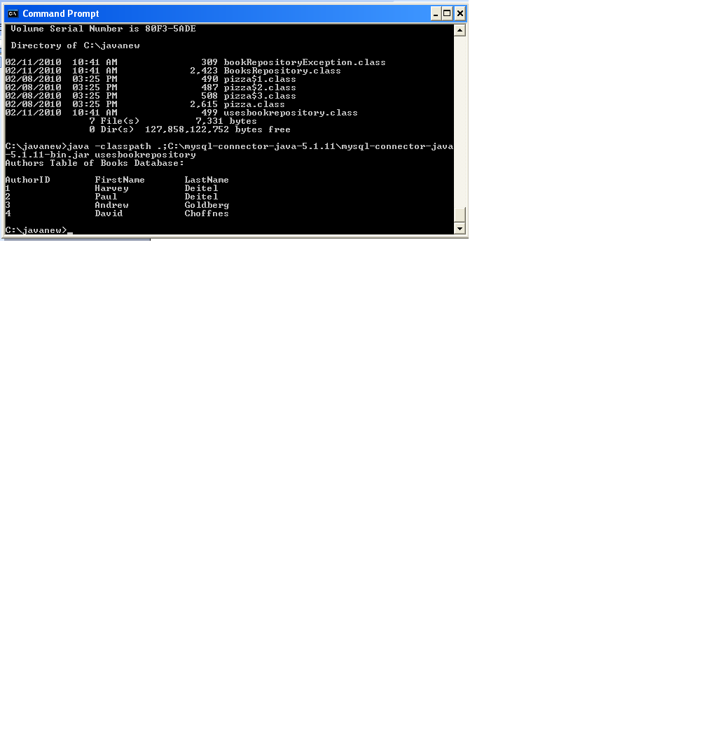
Ex. Add more statements.

Use derby.
Address book case study
C:\javanew\examples\examples\ch28\fig28_30_32

